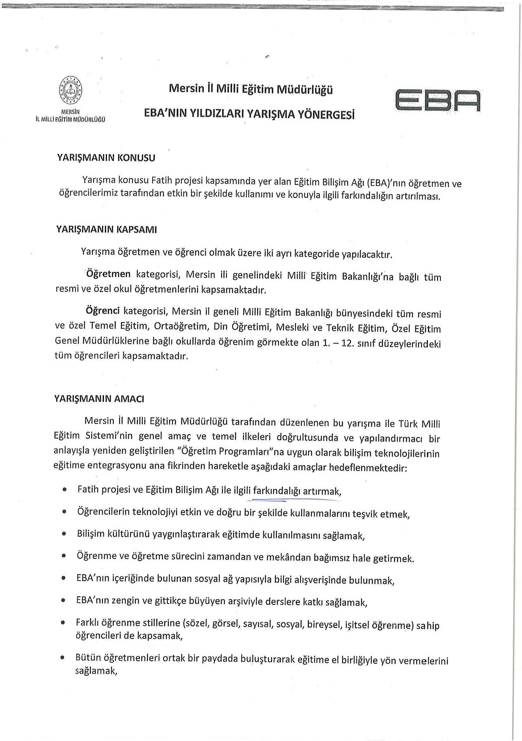

33181197 - 1633181197 - 1633181197 - 16331811

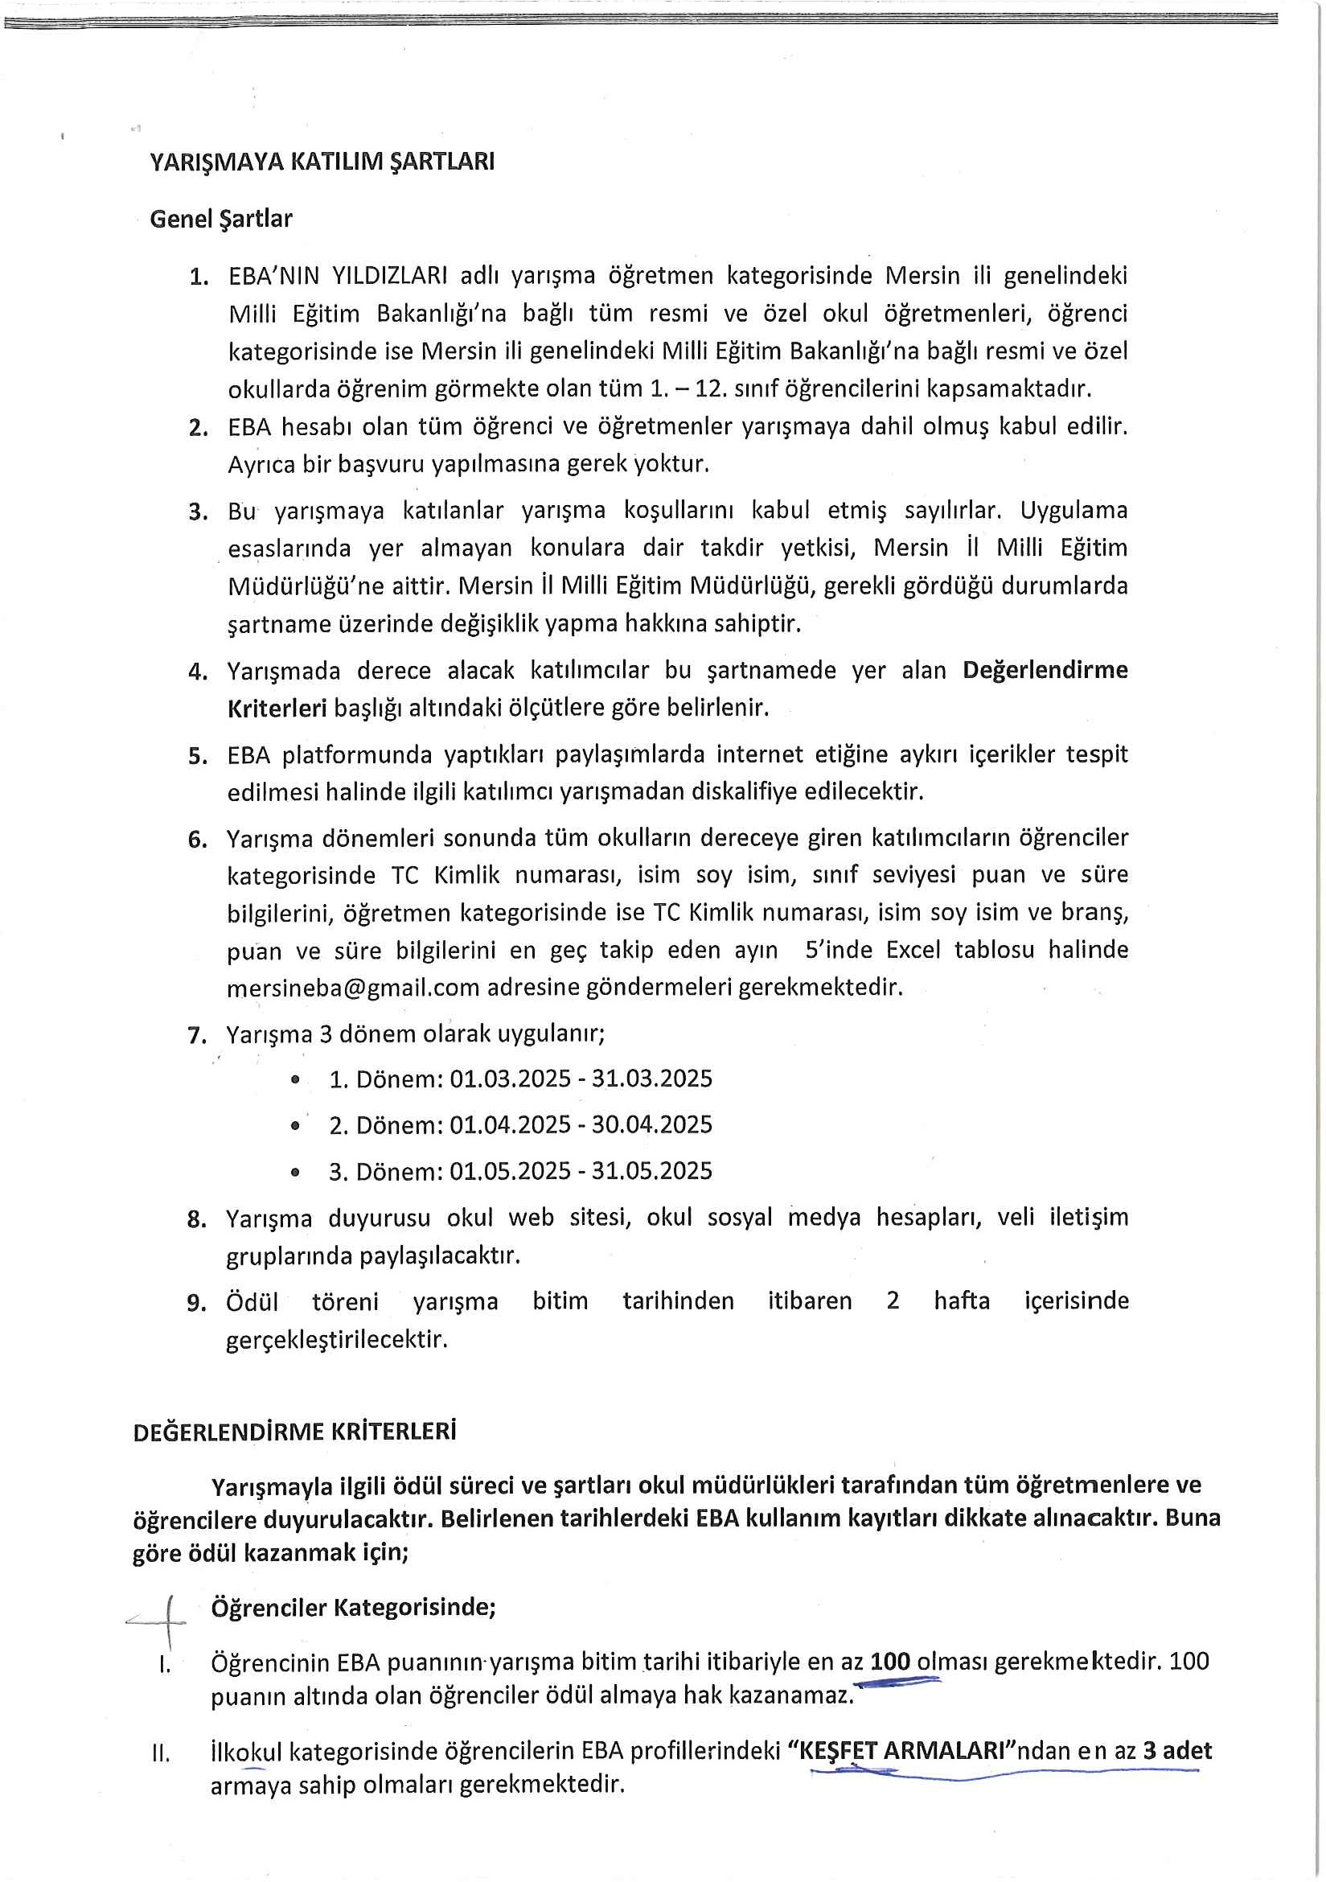

33181197 - 1633181197 - 1633181197 - 16331811

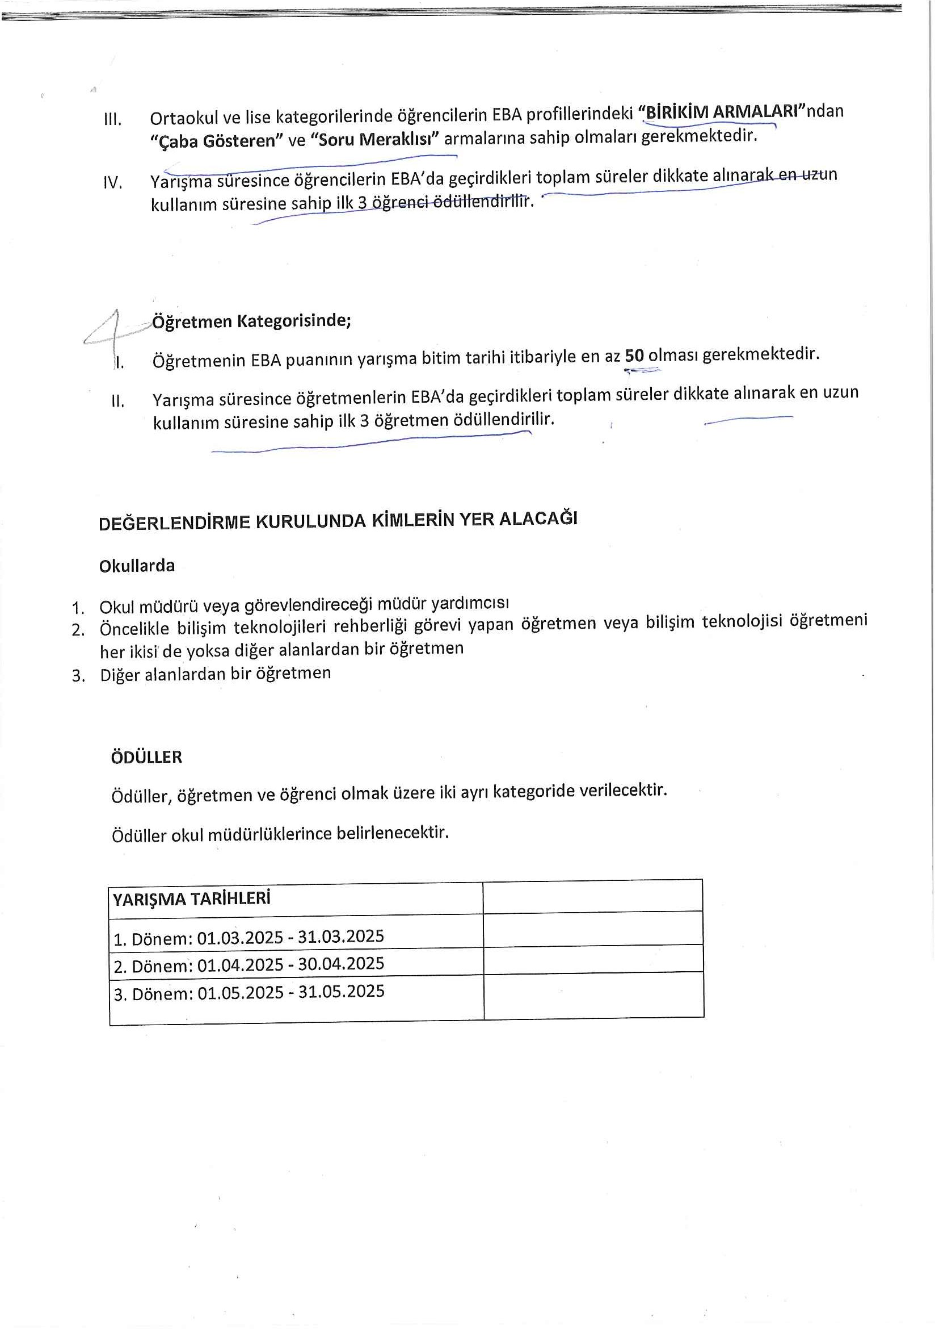

33181197 - 1633181197 - 1633181197 - 16331811